**Configuration 1:**

**Public cloud:**

Configuration details:

|  |  |
| --- | --- |
| Instance name | d2.8xlarge |
| Cost/hr | 5.52 |
| GFLOPS | 1382.4 |
| vCPU | 36 |
| RAM | 244 GiB |
| Storage | 256TB |
| Network | 10Gbps |
| Storage 100 PB Mothly cost | 2202572.8 |

Calculation of number of instances and utilizations:

|  |  |  |  |  |  |
| --- | --- | --- | --- | --- | --- |
| **Configuration No** | **Instance Count** | **Instance cost/hr** | **Instance Utilization** | **Utilization GFLOPS** | **Storage(PB)** |
|  |  |  |  |  |  |
| 1 | 1050 | 5796 | 25% | 345.6 | 100 |
| 2 | 1050 | 5796 | 50% | 691.2 | 100 |
| 3 | 1050 | 5796 | 75% | 1036.8 | 100 |
| 4 | 1050 | 5796 | 100% | 1382.4 | 100 |

*Continue:*

|  |  |  |  |  |  |  |  |
| --- | --- | --- | --- | --- | --- | --- | --- |
| **Conf no** | **Storage cost/hr** | **Cost/hr/GFLOPS** | **Total AWS cost/ hr (based on utilization)** | | **Total AWS cost/ 5 years** | | **Total AWS cost/ 5 years** |
|  |  |  | (Comment: Storage cost is fixed) | | (Comment: Storage cost is fixed) | | Storage cost and instance cost based on utilization |
| 1 | 2960.447312 | 25.33694245 | 4409.447312 | | ***193133792.3*** | | ***95883098.06*** |
| 2 | 2960.447312 | 12.66847123 | 5858.447312 | | ***256599992.3*** | | ***191766196.1*** |
| 3 | 2960.447312 | 8.445647484 | 7307.447312 | | ***320066192.3*** | | ***287649294.2*** |
| 4 | 2960.447312 | 6.334235613 | 8756.447312 | | ***383532392.3*** | | ***383532392.3*** |
| **5 Year cost 24*7 Utilization cost/hr/gflops** | | | | 277439.5199 | |
| **5 Year cost 24*7 Utilization cost** | | | | 383532392.3 | |

**Private cloud:**

|  |  |  |  |  |  |
| --- | --- | --- | --- | --- | --- |
|  | Description | Price per item($) | Quantity | Total($) | Comment |
|  |  |  |  |  |  |
| CPU | Intel Xeon e5-2676 v3 @ 2.40ghz (Haswell) processors | 5400 | 1050 | 5670000 | 3 Processors for 1 VM |
| Memory | [64GB PC4-21300 DDR4-2666Mhz Load Reduced ECC Quad Ranked 1.2V Major Brand](http://www.acmemicro.com/Product/15498/64GB-PC4-21300-DDR4-2666Mhz-Load-Reduced-ECC-Quad-Ranked-1-2V-Major-Brand?c_id=632) | 899.99 | 4200 | 3779958 | 4 Memory per vm |
| Disk | [6TB Seagate ST6000NM0105 - SAS 4Kn HDD 6TB V.5 Enterprise Capacity SAS 12Gb/s 7200rpm 256MB 3.5-inch Bulk](http://www.acmemicro.com/Product/15583/6TB-Seagate-ST6000NM0105---SAS-4Kn-HDD-6TB-V-5-Enterprise-Capacity-SAS-12Gb-s-7200rpm-256MB-3-5-inch-Bulk?c_id=240) | 248.99 | 6300 | 1568637 | 6 disk per vm |
| Motherboard | [ASUS Z10PE-D16 WS LGA 2011-v3 Intel C612 PCH SATA 6Gb/s USB 3.0 SSI EEB Intel Motherboard](https://www.newegg.com/Product/Product.aspx?Item=N82E16813132416&ignorebbr=1) | 498.99 | 1051 | 524438.49 | 1050 vm and extra 1 for storage server |
| Network Switch | [Mellanox SX1710 Ethernet SwitchX-2 based 36-port QSFP 40/56GbE 1U 36 QSFP ports 2 PS MSX1710-BS2F2](http://www.acmemicro.com/Product/15520/Mellanox-SX1710-Ethernet-SwitchX-2-based-36-port-QSFP-40-56GbE-1U-36-QSFP-ports-2-PS-MSX1710-BS2F2?c_id=424) | 11323 | 31 | 351013 | 30 for vm and 1 for upperone |
| Network Adapter | [Mellanox MCX415A-CCAT ConnectX-4 EN network interface card, 100GbE single-port QSFP28, PCIe3.0 x16, tall bracket](http://www.acmemicro.com/Product/15512/Mellanox-MCX415A-CCAT-ConnectX-4-EN-network-interface-card-100GbE-single-port-QSFP28-PCIe3-0-x16-tall-bracket?c_id=424) | 758.24 | 31 | 23505.44 | same as network switch |
| Network Cable | [Belkin A3L791b14-BLU-S 14 ft. Cat 5E Blue Patch Cable](https://www.newegg.com/Product/Product.aspx?Item=N82E16812107406&ignorebbr=1) | 9.99 | 1085 | 10839.15 | vm + switch + extra 4 |
| Server Racks | [iStarUSA WD-1045 10U 450mm Depth Simple Server Rack](https://www.newegg.com/Product/Product.aspx?Item=N82E16816215327&ignorebbr=1) | 228.99 | 105 | 24043.95 | 10vm per rack |
| Storage server | J4601S, HGST 4U 60 Bay JBOD with 60 * 12TB Helium SAS SSD (Kepler+) | 44250 | 139 | 6150750 | 100PB/720TB |
| Electric Power | Chicago Electricity cost 7.15 per kWh. Power consumed per cpu: 120 watts/hr |  |  | 1182126.96 |  |
| Cooling | Chicago Electricity cost 7.15 per kWh. Power consumed per cpu: 120 watts/hr |  |  | 900748.4339 |  |
| Admin | 70000 per year salary | 70000 | 2 | 700000 |  |
|  |  |  |  |  |  |
|  |  |  | TOTAL: | ***20886060.42*** |  |

|  |  |  |  |  |  |  |  |
| --- | --- | --- | --- | --- | --- | --- | --- |
| **Configuration No** | **Instance Count** | **Instance cost/hr** | **Instance Utilization** | **Utilization GFLOPS** | **Storage(PB)** | **Storage cost/hr** | **Cost/hr/GFLOPS** |
|  |  |  |  |  |  |  |  |
| 1 | 1050 | 84.1056531 | 25% | 345.6 | 100 | 140.4280822 | 0.649692521 |
| 2 | 1050 | 168.2113062 | 50% | 691.2 | 100 | 140.4280822 | 0.446526893 |
| 3 | 1050 | 252.3169593 | 75% | 1036.8 | 100 | 140.4280822 | 0.378805017 |
| 4 | 1050 | 336.4226124 | 100% | 1382.4 | 100 | 140.4280822 | 0.344944079 |

|  |  |
| --- | --- |
| **5 Year cost 24*7 Utilization cost/hr/gflops** | 15108.55065 |
| **5 Year cost 24*7 Utilization cost** | 20886060.42 |

So, based on above analysis we have plotted graphs as follows:

Compare AWS (Storage cost and instance cost based on utilization) and private cloud:

As per above, we can say that private cloud is the best option in 5 years of time.

**Configuration 2:**

**Public cloud:**

Configuration details:

|  |  |
| --- | --- |
| Instance name | r3.large |
| Cost/hr | 0.166 |
| GFLOPS | 40 |
| vCPU | 2 |
| RAM | 15.25GB |
| Storage | 32GB |
| Network | Moderate |
| Storage 10 PB Mothly cost | 220764.16 |

Calculation of number of instances and utilizations:

|  |  |  |  |  |  |
| --- | --- | --- | --- | --- | --- |
| **Configuration No** | **Instance Count** | **Instance cost/hr** | **Instance Utilization** | **Utilization GFLOPS** | **Storage(PB)** |
|  |  |  |  |  |  |
| 1 | 1000000 | 166000 | 25% | 10 | 10 |
| 2 | 1000000 | 166000 | 50% | 20 | 10 |
| 3 | 1000000 | 166000 | 75% | 30 | 10 |
| 4 | 1000000 | 166000 | 100% | 40 | 10 |

*Continue:*

|  |  |  |  |  |  |  |  |  |
| --- | --- | --- | --- | --- | --- | --- | --- | --- |
| **Conf. No.** | **Storage cost/hr** | **Cost/hr/GFLOPS** | **Total AWS cost/ hr (based on utilization)** | | **Total AWS cost/ 5 years** | | **Total AWS cost/ 5 years** | |
|  |  |  | (Comment: Storage cost is fixed) | (Comment: Storage cost is fixed) | | Storage cost and instance cost based on utilization | |
| 1 | 296.7260215 | 16629.6726 | 41796.72602 | ***1830696600*** | | ***1820949150*** | |
| 2 | 296.7260215 | 8314.836301 | 83296.72602 | ***3648396600*** | | ***3641898300*** | |
| 3 | 296.7260215 | 5543.224201 | 124796.726 | ***5466096600*** | | ***5462847450*** | |
| 4 | 296.7260215 | 4157.418151 | 166296.726 | ***7283796600*** | | ***7283796600*** | |

|  |  |
| --- | --- |
| **5 Year cost 24*7 Utilization cost/hr/gflops** | 182094915 |
| **5 Year cost 24*7 Utilization cost** | 7283796600 |

**Private cloud:**

|  |  |  |  |  |  |
| --- | --- | --- | --- | --- | --- |
|  | Description | Price per item($) | Quantity | Total($) | Comment |
|  |  |  |  |  |  |
| CPU | Intel Xeon E5-2670 v2 Ivy Bridge-EP 2.5 GHz 25MB L3 Cache LGA 2011 115W BX80635E52670V2 Server Processor | 1550 | 1000000 | 1550000000 |  |
| Memory | [16GB PC4-19200 DDR4-2400Mhz Registered ECC DIMM 1.2V Major Brand](http://www.acmemicro.com/Product/15498/64GB-PC4-21300-DDR4-2666Mhz-Load-Reduced-ECC-Quad-Ranked-1-2V-Major-Brand?c_id=632) | 210.99 | 1000000 | 210990000 | 1 Memory per vm |
| Disk | [Intel 32GB MEMPEK1W032GAXT Optane Memory Series NVMe PCIe M.2 2280 1350MB/sec Read 20nm 3D Xpoint, Retail](http://www.acmemicro.com/Product/15583/6TB-Seagate-ST6000NM0105---SAS-4Kn-HDD-6TB-V-5-Enterprise-Capacity-SAS-12Gb-s-7200rpm-256MB-3-5-inch-Bulk?c_id=240) | 96.99 | 1000000 | 96990000 | 1 disk per vm |
| Motherboard | [ASUS Z10PE-D16 WS LGA 2011-v3 Intel C612 PCH SATA 6Gb/s USB 3.0 SSI EEB Intel Motherboard](https://www.newegg.com/Product/Product.aspx?Item=N82E16813132416&ignorebbr=1) | 498.99 | 1000001 | 498990499 | 1 million vm and extra 1 for storage server |
| Network Switch | [Mellanox SX1710 Ethernet SwitchX-2 based 36-port QSFP 40/56GbE 1U 36 QSFP ports 2 PS MSX1710-BS2F2](http://www.acmemicro.com/Product/15520/Mellanox-SX1710-Ethernet-SwitchX-2-based-36-port-QSFP-40-56GbE-1U-36-QSFP-ports-2-PS-MSX1710-BS2F2?c_id=424) | 11323 | 28573 | 323532079 | 1million/35 for vm and 1 for upperone |
| Network Adapter | [Mellanox MCX415A-CCAT ConnectX-4 EN network interface card, 100GbE single-port QSFP28, PCIe3.0 x16, tall bracket](http://www.acmemicro.com/Product/15512/Mellanox-MCX415A-CCAT-ConnectX-4-EN-network-interface-card-100GbE-single-port-QSFP28-PCIe3-0-x16-tall-bracket?c_id=424) | 758.24 | 28573 | 21665191.52 | same as network switch |
| Network Cable | [Belkin A3L791b14-BLU-S 14 ft. Cat 5E Blue Patch Cable](https://www.newegg.com/Product/Product.aspx?Item=N82E16812107406&ignorebbr=1) | 9.99 | 1028580 | 10275514.2 | vm + switch + extra 7 |
| Server Racks | [iStarUSA WD-1045 10U 450mm Depth Simple Server Rack](https://www.newegg.com/Product/Product.aspx?Item=N82E16816215327&ignorebbr=1) | 228.99 | 100000 | 22899000 | 10vm per rack |
| Storage server | J4601S, HGST 4U 60 Bay JBOD with 60 * 12TB Helium SAS SSD (Kepler+) | 44250 | 14 | 619500 | 10PB/720TB |
| Electric Power | Chicago Electricity cost 7.15 per kWh. Power consumed per cpu: 202 watts/hr |  |  | 110759.25 |  |
| Cooling | Chicago Electricity cost 7.15 per kWh. Power consumed per cpu: 202 watts/hr |  |  | 71320000 |  |
| Admin | 70000 per year salary | 70000 | 1000 | 350000000 |  |
|  |  |  |  |  |  |
|  |  |  |  | 3157392543 |  |

|  |  |  |  |  |  |  |  |
| --- | --- | --- | --- | --- | --- | --- | --- |
| **Configuration No** | **Instance Count** | **Instance cost/hr** | **Instance Utilization** | **Utilization GFLOPS** | **Storage(PB)** | **Storage cost/hr** | **Cost/hr/GFLOPS** |
|  |  |  |  |  |  |  |  |
| 1 | 1050 | 18018.11098 | 25% | 10 | 100 | 14.14383562 | 1803.225481 |
| 2 | 1050 | 36036.22195 | 50% | 20 | 100 | 14.14383562 | 1802.518289 |
| 3 | 1050 | 54054.33293 | 75% | 30 | 100 | 14.14383562 | 1802.282559 |
| 4 | 1050 | 72072.4439 | 100% | 40 | 100 | 14.14383562 | 1802.164693 |

|  |  |
| --- | --- |
| **5 Year cost 24*7 Utilization cost/hr/gflops** | 78934813.57 |
| **5 Year cost 24*7 Utilization cost** | 3157392543 |

So, based on above analysis we have plotted graphs as follows:

Compare AWS (Storage cost and instance cost based on utilization) and private cloud:

As per above, we can say that if our utilization is less than 45% then public cloud(AWS) is the best choice. Otherwise private cloud is the best option in 5 years of time.

**Configuration 3:**

**Public cloud:**

Configuration details:

|  |  |
| --- | --- |
| Instance name | p3.16xLarge |
| Cost/hr | 24.48 |
| TeraFLOPS | 1000 |
| vCPU | 64 |
| GPU | 8 |
| RAM | 488GB |
| GPU Memory | 128GB |
| Storage | 32GB |
| Network | 25 |
| Storage 1 PB Monthly cost | 22583.3 |

Calculation of number of instances and utilizations:

|  |  |  |  |  |  |
| --- | --- | --- | --- | --- | --- |
| **Configuration No** | **Instance Count** | **Instance cost/hr** | **Instance Utilization** | **Utilization TeraFLOPS** | **Storage(PB)** |
|  |  |  |  |  |  |
| 1 | 1000 | 24480 | 25% | 250 | 1 |
| 2 | 1000 | 24480 | 50% | 500 | 1 |
| 3 | 1000 | 24480 | 75% | 750 | 1 |
| 4 | 1000 | 24480 | 100% | 1000 | 1 |

*Continue:*

|  |  |  |  |  |  |  |  |  |  |
| --- | --- | --- | --- | --- | --- | --- | --- | --- | --- |
| **Conf. No.** |  |  |  |  | **Storage cost/hr** | **Cost/hr/TeraFLOPS** | **Total AWS cost/ hr (based on utilization)** | **Total AWS cost/ 5 years** | **Total AWS cost/ 5 years** |
|  |  |  |  |  |  |  | (Comment: Storage cost is fixed) | (Comment: Storage cost is fixed) | Storage cost and instance cost based on utilization |
| 1 |  |  |  |  | 30.35389785 | 98.04141559 | 6150.353898 | ***269385500.7*** | ***268388375.2*** |
| 2 |  |  |  |  | 30.35389785 | 49.0207078 | 12270.3539 | ***537441500.7*** | ***536776750.4*** |
| 3 |  |  |  |  | 30.35389785 | 32.68047186 | 18390.3539 | ***805497500.7*** | ***805165125.5*** |
| 4 |  |  |  |  | 30.35389785 | 24.5103539 | 24510.3539 | ***1073553501*** | ***1073553501*** |

|  |  |
| --- | --- |
| **5 Year cost 24*7 Utilization cost/hr/TeraFiops** | 1073553.501 |
| **5 Year cost 24*7 Utilization cost** | 1073553501 |

**Private cloud:**

|  |  |  |  |  |  |
| --- | --- | --- | --- | --- | --- |
|  | Description | Price per item($) | Quantity | Total($) | Comment |
|  |  |  |  |  |  |
| CPU | Intel Xeon E5 2686 V4 SR2K8 18Core 2.3Ghz 45MB LGA2011-3 145W 14nm Processor CPU | 1119 | 4000 | 4476000 | 4 per vm |
| Memory | [64GB PC4-21300 DDR4-2666Mhz Load Reduced ECC Quad Ranked 1.2V Major Brand](http://www.acmemicro.com/Product/15498/64GB-PC4-21300-DDR4-2666Mhz-Load-Reduced-ECC-Quad-Ranked-1-2V-Major-Brand?c_id=632) | 899.99 | 8000 | 7199920 | 8 Memory per vm |
| Disk | [Intel 32GB MEMPEK1W032GAXT Optane Memory Series NVMe PCIe M.2 2280 1350MB/sec Read 20nm 3D Xpoint, Retail](http://www.acmemicro.com/Product/15583/6TB-Seagate-ST6000NM0105---SAS-4Kn-HDD-6TB-V-5-Enterprise-Capacity-SAS-12Gb-s-7200rpm-256MB-3-5-inch-Bulk?c_id=240) | 96.99 | 1000 | 96990 | 1 disk per vm |
| GPU | [NVIDIA TESLA V100 PCIE 16GB MODULE](http://www.nextwarehouse.com/item/?2782569) | 18650 | 8000 | 149200000 | 8 GPU per vm |
| Motherboard | [ASUS Z10PE-D16 WS LGA 2011-v3 Intel C612 PCH SATA 6Gb/s USB 3.0 SSI EEB Intel Motherboard](https://www.newegg.com/Product/Product.aspx?Item=N82E16813132416&ignorebbr=1) | 498.99 | 1001 | 499488.99 | 1000 vm and extra 1 for storage server |
| Network Switch | [Mellanox SX1710 Ethernet SwitchX-2 based 36-port QSFP 40/56GbE 1U 36 QSFP ports 2 PS MSX1710-BS2F2](http://www.acmemicro.com/Product/15520/Mellanox-SX1710-Ethernet-SwitchX-2-based-36-port-QSFP-40-56GbE-1U-36-QSFP-ports-2-PS-MSX1710-BS2F2?c_id=424) | 11323 | 30 | 339690 | 1000/35 for vm and 1 for upperone |
| Network Adapter | [Mellanox MCX415A-CCAT ConnectX-4 EN network interface card, 100GbE single-port QSFP28, PCIe3.0 x16, tall bracket](http://www.acmemicro.com/Product/15512/Mellanox-MCX415A-CCAT-ConnectX-4-EN-network-interface-card-100GbE-single-port-QSFP28-PCIe3-0-x16-tall-bracket?c_id=424) | 758.24 | 30 | 22747.2 | same as network switch |
| Network Cable | [Belkin A3L791b14-BLU-S 14 ft. Cat 5E Blue Patch Cable](https://www.newegg.com/Product/Product.aspx?Item=N82E16812107406&ignorebbr=1) | 9.99 | 1035 | 10339.65 | vm + switch + extra 5 |
| Server Racks | [iStarUSA WD-1045 10U 450mm Depth Simple Server Rack](https://www.newegg.com/Product/Product.aspx?Item=N82E16816215327&ignorebbr=1) | 228.99 | 100 | 22899 | 10vm per rack |
| Storage server | J4601S, HGST 4U 60 Bay JBOD with 60 * 6TB Helium SAS SSD (Kepler+) | 26024.27 | 3 | 78072.81 | 10PB/720TB |
| Electric Power | Chicago Electricity cost 7.15 per kWh. Power consumed per cpu: 120 watts/hr |  |  | 938196 |  |
| Cooling | Chicago Electricity cost 7.15 per kWh. Power consumed per cpu: 120 watts/hr |  |  | 714878.5455 |  |
| Admin | 70000 per year salary | 70000 | 1 | 350000 |  |
|  |  |  |  |  |  |
|  |  |  |  | ***163949222.2*** |  |

|  |  |  |  |  |  |  |  |
| --- | --- | --- | --- | --- | --- | --- | --- |
| **Configuration No** | **Instance Count** | **Instance cost/hr** | **Instance Utilization** | **Utilization TeraFLOPS** | **Storage(PB)** | **Storage cost/hr** | **Cost/hr/TeraFLOPS** |
|  |  |  |  |  |  |  |  |
| 1 | 1050 | 935.3376106 | 25% | 250 | 100 | 1.782484247 | 3.74848038 |
| 2 | 1050 | 1870.675221 | 50% | 500 | 100 | 1.782484247 | 3.744915411 |
| 3 | 1050 | 2806.012832 | 75% | 750 | 100 | 1.782484247 | 3.743727088 |
| 4 | 1050 | 3741.350443 | 100% | 1000 | 100 | 1.782484247 | 3.743132927 |

|  |  |
| --- | --- |
| **5 Year cost 24*7 Utilization cost/hr/gflops** | 163949.2222 |
| **5 Year cost 24*7 Utilization cost** | 163949222.2 |

So, based on above analysis we have plotted graphs as follows:

Compare AWS (Storage cost and instance cost based on utilization) and private cloud:

As per above, we can say that private cloud is the best option in 5 years of time.

**Summary Table:**

|  |  |  |  |
| --- | --- | --- | --- |
|  | Configuration 1 | Configuration 2 | Configuration 3 |
| Public Cloud (including EC2 and S3) Cost over 5 years, 24/7 operation, with 100% usage | 383532392.3 | 7283796600 | 1073553501 |
| Private Cloud cost over 5 years, 24/7 operation, with 100% usage | *20886060.42* | 3157392543 | 163949222.2 |
| What utilization must be achieved with the private cloud to make the private cloud option more attractive than the public cloud? | Private cloud more efficient. | Utilization around 45%. | Private cloud more efficient. |

**Shopping cart:**

Memory:

[**64GB PC4-21300 DDR4-2666Mhz Load Reduced ECC Quad Ranked 1.2V Major Brand**](http://www.acmemicro.com/Product/15498/64GB-PC4-21300-DDR4-2666Mhz-Load-Reduced-ECC-Quad-Ranked-1-2V-Major-Brand?c_id=632)

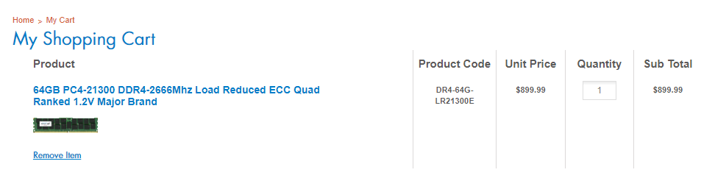

Disk:

[**6TB Seagate ST6000NM0105 - SAS 4Kn HDD 6TB V.5 Enterprise Capacity SAS 12Gb/s 7200rpm 256MB 3.5-inch Bulk**](http://www.acmemicro.com/Product/15583/6TB-Seagate-ST6000NM0105---SAS-4Kn-HDD-6TB-V-5-Enterprise-Capacity-SAS-12Gb-s-7200rpm-256MB-3-5-inch-Bulk?c_id=240)

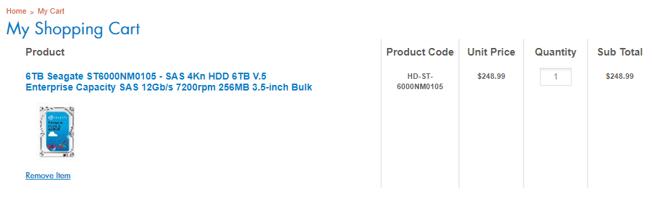

Motherboard:

[**ASUS Z10PE-D16 WS LGA 2011-v3 Intel C612 PCH SATA 6Gb/s USB 3.0 SSI EEB Intel Motherboard**](https://www.newegg.com/Product/Product.aspx?Item=N82E16813132416&ignorebbr=1)

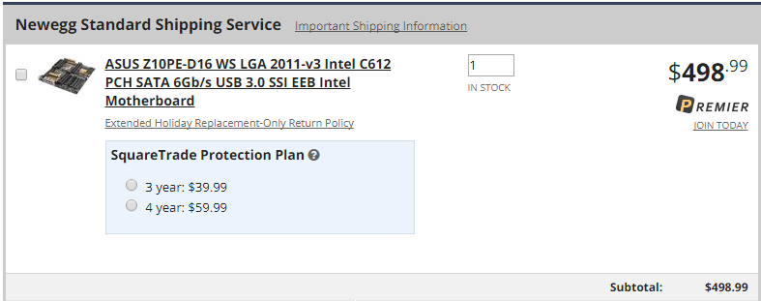

Network Switch:

[**Mellanox SX1710 Ethernet SwitchX-2 based 36-port QSFP 40/56GbE 1U 36 QSFP ports 2 PS MSX1710-BS2F2**](http://www.acmemicro.com/Product/15520/Mellanox-SX1710-Ethernet-SwitchX-2-based-36-port-QSFP-40-56GbE-1U-36-QSFP-ports-2-PS-MSX1710-BS2F2?c_id=424)

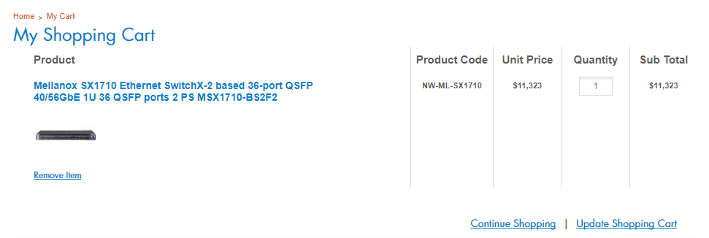

Network Adapter:

[**Mellanox MCX415A-CCAT ConnectX-4 EN network interface card, 100GbE single-port QSFP28, PCIe3.0 x16, tall bracket**](http://www.acmemicro.com/Product/15512/Mellanox-MCX415A-CCAT-ConnectX-4-EN-network-interface-card-100GbE-single-port-QSFP28-PCIe3-0-x16-tall-bracket?c_id=424)

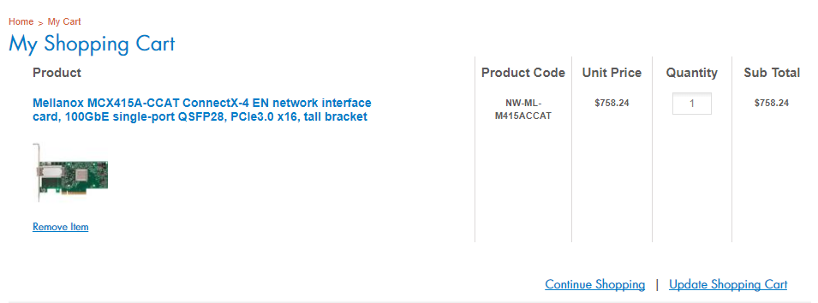

Network cable:

[**Belkin A3L791b14-BLU-S 14 ft. Cat 5E Blue Patch Cable**](https://www.newegg.com/Product/Product.aspx?Item=N82E16812107406&ignorebbr=1)

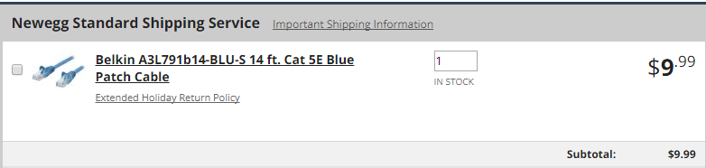

Server Rack:

[**iStarUSA WD-1045 10U 450mm Depth Simple Server Rack**](https://www.newegg.com/Product/Product.aspx?Item=N82E16816215327&ignorebbr=1)

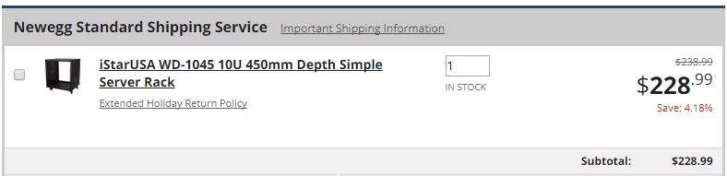

Storage server:

J4601S**,** HGST 4U 60 Bay JBOD with 60 * 12TB Helium SAS SSD (Kepler+)

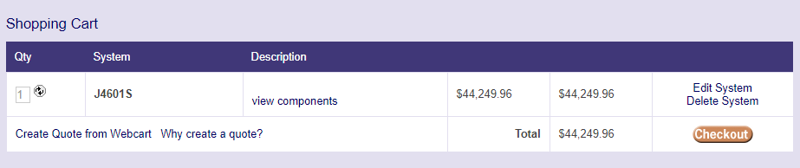

Configuration 2

CPU:

Intel Xeon E5-2670 v2 Ivy Bridge-EP 2.5 GHz 25MB L3 Cache LGA 2011 115W BX80635E52670V2 Server Processor

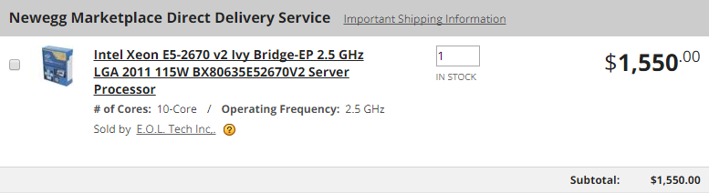

Memory:

[16GB PC4-19200 DDR4-2400Mhz Registered ECC DIMM 1.2V Major Brand](http://www.acmemicro.com/Product/14893/16GB-PC4-19200-DDR4-2400Mhz-Registered-ECC-DIMM-1-2V-Major-Brand?c_id=629)

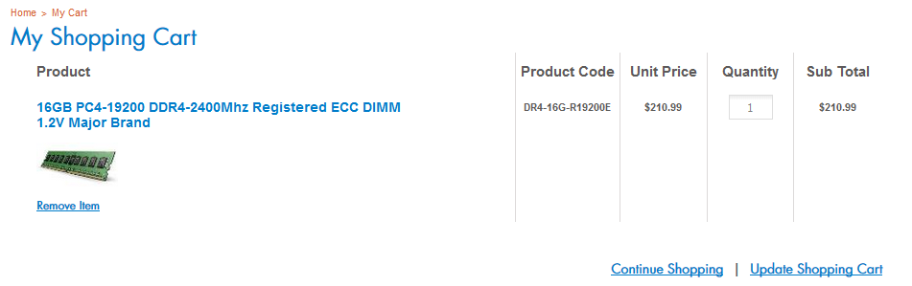

Disk:

[Intel 32GB MEMPEK1W032GAXT Optane Memory Series NVMe PCIe M.2 2280 1350MB/sec Read 20nm 3D Xpoint, Retail](http://www.acmemicro.com/Product/15735/Intel-32GB-MEMPEK1W032GAXT-Optane-Memory-Series-NVMe-PCIe-M-2-2280-1350MB-sec-Read-20nm-3D-Xpoint-Retail?c_id=670)

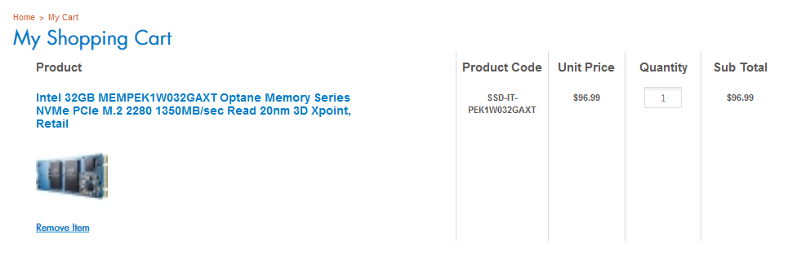

Configuration 3

CPU:

Intel Xeon E5 2686 V4 SR2K8 18Core 2.3Ghz 45MB LGA2011-3 145W 14nm Processor CPU

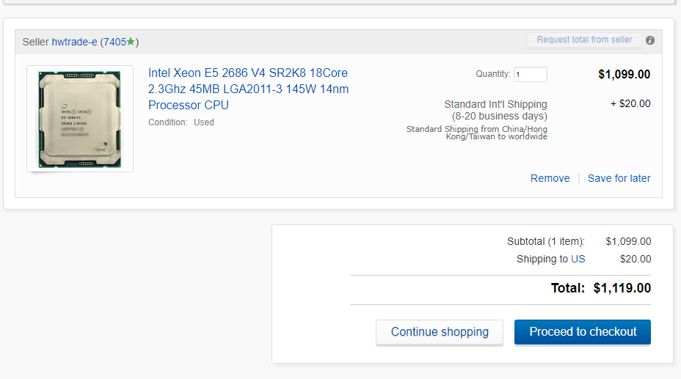

Storage:

J4601S**,** HGST 4U 60 Bay JBOD with 60 * 6TB Helium SAS SSD (Kepler+)

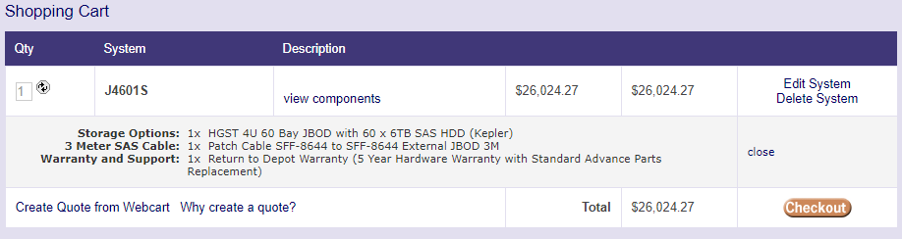

GPU:

[**NVIDIA TESLA V100 PCIE 16GB MODULE**](http://www.nextwarehouse.com/item/?2782569)

